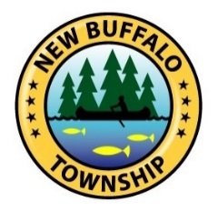
NEW BUFFALO TOWNSHIP
17425 Red Arrow Hwy
New Buffalo, Michigan 49117
Ph: (269) 469-1011

The New Buffalo Township Parks Committee would like your input to help determine park and recreation priorities for our community. This survey will only take a minute to complete. When you are finished please turn it in to one of our parks staff.

Please complete the survey by checking the appropriate box or filling in the blank with your answer.

- My house is located in:

- New Buffalo Township
- City of New Buffalo
- Chikaming Township
- Other __________________

- My household consists of the following age groups (please check all that apply)

- 0-5
- 6-12
- 13-18
- 19-25
- 26-35
- 36-45
- 46-55
- 56-65
- 66+

- Does anyone in your household have special accessibility needs for park amenities?

- Yes

- No

- Which facilities and/or recreational activities at New Buffalo Township Parks have you or any member of your household enjoyed? Please list all facilities/activities that apply:

- What additional recreational activities and/or programs would you or any member of your household benefit from the Township adding to the Parks and Recreation Program? Please list all activities/programs that apply:

- Would you use or support an off road bicycle/pedestrian pathway in New Buffalo Township?

- Yes
- No

- Which of the following recreational opportunities would you or any member of your family use if it was available in the Township? Please check all that apply.

- Sledding hill/ Ice skating rink/ warming lodge
- Kayaking/ Canoeing/ Fishing
- Cultural/ Physical fitness class (painting, yoga, etc.)
- Other (please list)_____________________
- Primitive campground
- Other please list_____________________

